Sunday | Monday | Tuesday | Wednesday | Thursday | Friday | Saturday
 |  |  |  |  | 1 | 2
3 | 4 | 5 | 6 | 7 | 8 | 9
10  Ramadan Begins  Daylight Saving Time Begins | 11 | 12 | 13 | 14 | 15 | 16
17  St. Patrick’s Day | 18 | 19  Spring Begins | 20 | 21 | 22 | 23  Purim Begins
24  Palm Sunday | 25 | 26 | 27 | 28 | 29 | 30
31

Easter Sunday

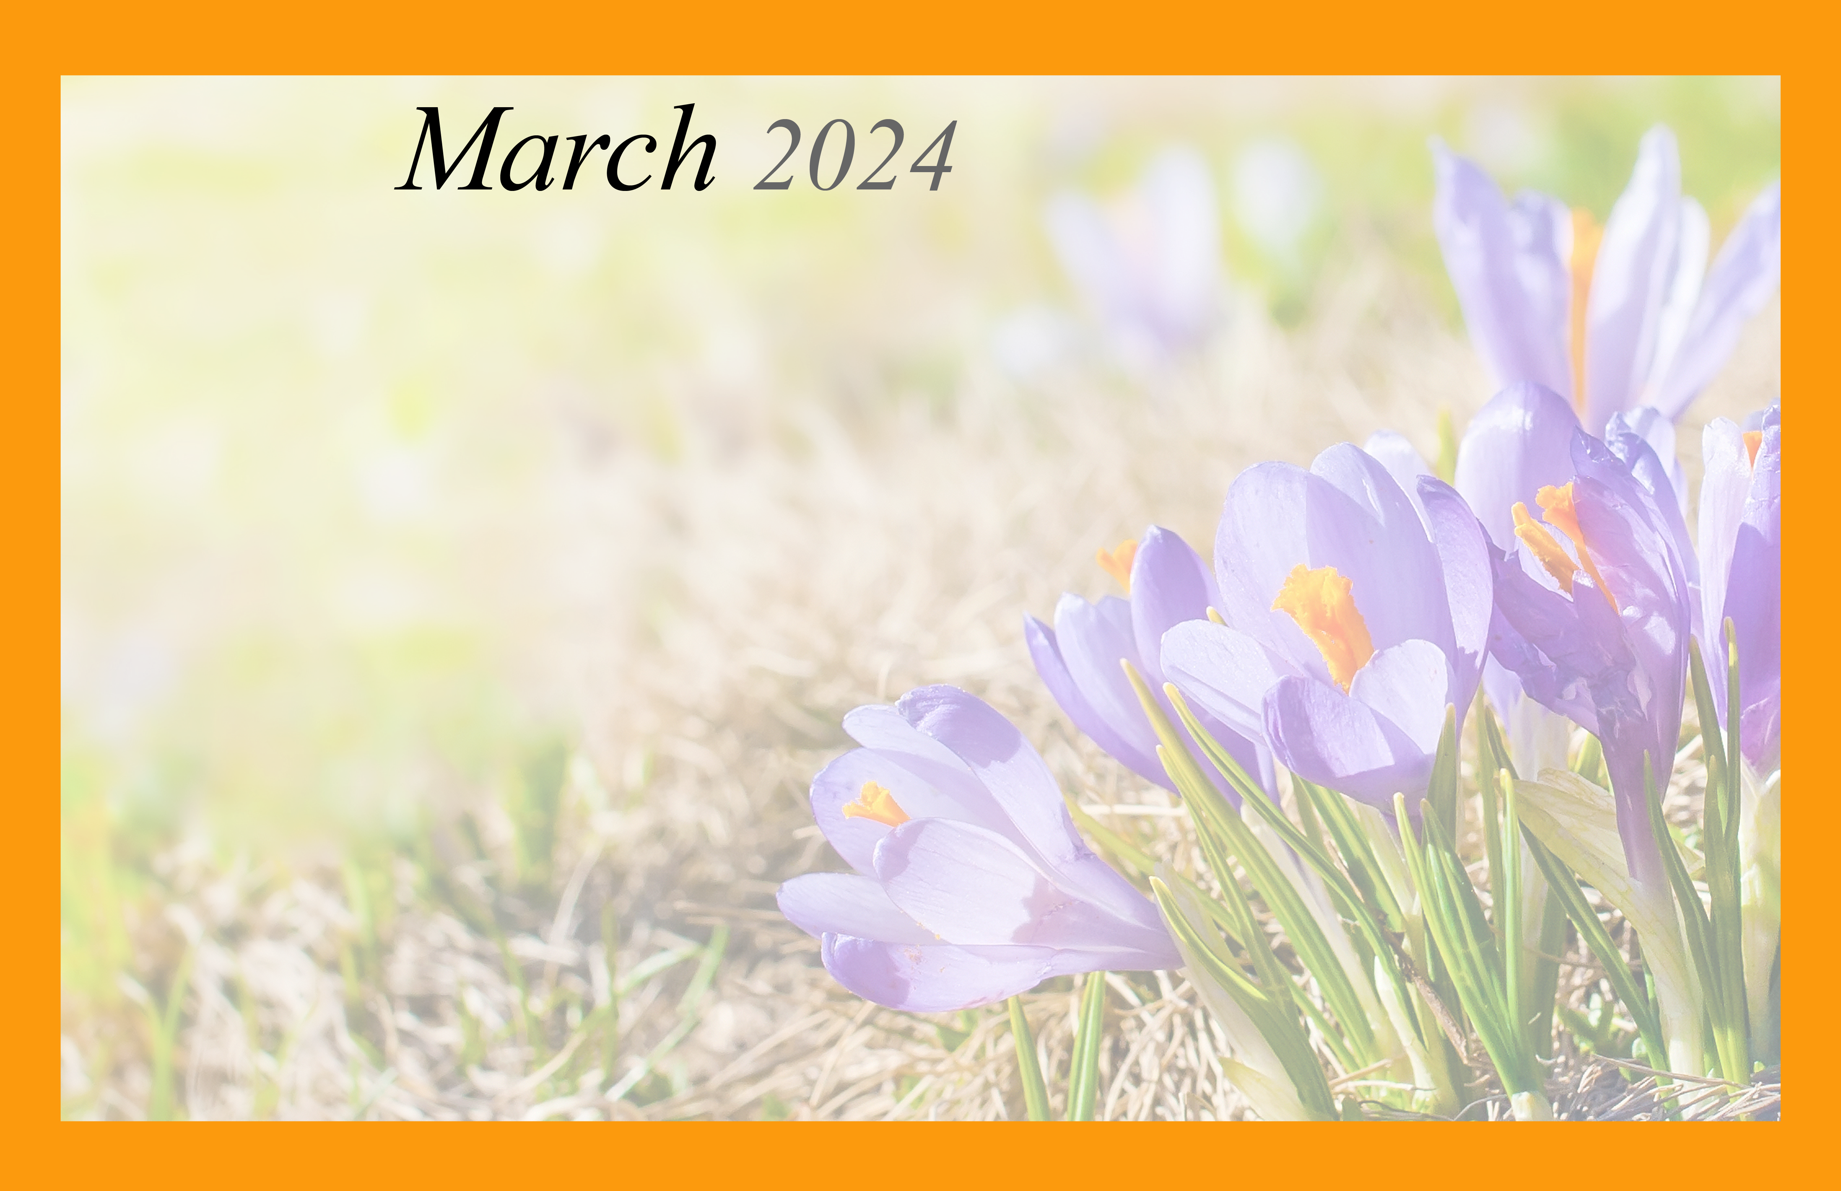  Inlet Coastal Resort Memory Care |  |  |  |  | 9:00 Morning Hello and  Conversation  10:00 Word Book Games  1:30 Making Memories-around the Table Talk  2:00 Music with Tom  6:00 Evening Movie  Love on a Leash! | 9:00 Morning Hello and Conversation  10:00 Word Search Fun  1:30 Making Memories-around the Table Talk  3:00 Ball Toss  6:00 Evening Movie
9:00 Morning Hello and Conversation  10:00 Mass on Television  1:30 Puzzle Time around the table  3:00 Sundaes Sunday  6:00 Evening Movie | 9:00 Morning Hello and Conversation  10:00 Sorting Time  1:30 Afternoon Walk and Conversation  3:00 Memories with Paper Crafting | 9:00 Morning Meet & Greet  10:00 Folding and Organizing  1:30 Afternoon Walk and Conversation  3:00 Creative Adult Coloring  6:00 Evening Movie | 9:00 Morning Hello and Conversation  10:00 Organization Time  1:30 Afternoon Walk and Conversation  2:00 Music Therapy w/Leah  6:00 Evening Movie  Lily the dog visits! | 9:00 Morning Meet & Greet  10:00 Folding and Organizing  1:30 Afternoon Walk and Conversation  3:00 Card Games  6:00 Evening Movie | 9:00Morning Hello and Conversation  10:00 Word Book Games  1:30 Making Memories-around the Table Talk  2:00 Music with Tom  6:00 Evening Movie  Love on a Leash! | 9:00 Morning Hello and Conversation  10:00 Word Search Fun  1:30 Making Memories around the Table Talk  3:00 Ball Toss  6:00 Evening Movie
9:00 Morning Hello and Conversation  10:00 Mass on Television  1:30 Puzzle Time around the table  3:00 Sundaes Sunday  6:00 Evening Movie | 9:00 Morning Hello and Conversation  10:00 Sorting Time  1:30 Afternoon Walk and Conversation  3:00 Memories with Paper Crafting  6:00 Evening Movie | 9:00 Morning Meet & Greet  10:00 Folding and Organizing  1:30 Afternoon Walk and Conversation  3:00 Creative Adult Coloring  6:00 Evening Movie | 9:00 Morning Hello and Conversation  10:00 Organization Time  1:30 Afternoon Walk and Conversation  3:00 Magazine Reading with Conversation  Lily the dog visits! | 9:00 Morning Meet & Greet  10:00 Folding and Organizing  1:30 Afternoon Walk and Conversation  3:00 Card Games  6:00 Evening Movie | 9:00 Morning Hello and Conversation  10:00 Word Book Games  1:30 Making Memories-around the Table Talk  2:00 Music with Tom  6:00 Evening Movie  Love on a Leash! | 9:00 Morning Hello and Conversation  10:00 Word Search Fun  1:30 Making Memories around the Table Talk  3:00 Ball Toss  6:00 Evening Movie
9:00 Morning Hello and Conversation  10:00 Mass on Television  1:30 Puzzle Time around the table  3:00 Sundaes Sunday & St. Patrick’s Day Treats!  6:00 Evening Movie | 9:00 Morning Hello and Conversation  10:00 Sorting Time  1:30 Afternoon Walk and Conversation  3:00 Memories with Paper  Crafting  6:00 Evening Movie | 9:00 Morning Hello and Conversation  10:00 Folding and Organizing  1:30 Afternoon Walk and Conversation  3:00 Creative Adult Coloring  6:00 Evening Movie | 9:00 Morning Hello and Conversation  10:00 Organization Time  2:00 Music Therapy w/Leah  3:00 Magazine Reading with Conversation  Lily the dog visits! | 9:00 Morning Meet & Greet  10:00 Folding and Organizing  1:30 Afternoon Walk and Conversation  3:00 Card Games  6:00 Evening Movie | 9:00 Morning Hello and Conversation  10:00 Word Book Games  1:30 Making Memories-around the Table Talk  2:00 Music with Tom  6:00 Evening Movie  Love on a Leash! | 9:00 Morning Hello and Conversation  10:00 Word Search Fun  1:30 Making Memories around the Table Talk  3:00 Bean Bag Toss  6:00 Evening Movie
9:00 Morning Hello and Conversation  10:00 Mass on Television  1:30 Puzzle Time around the table  3:00 Sundaes Sunday  6:00 Evening Movie | 9:00 Morning Hello and Conversation  10:00 Sorting Time  1:30 Afternoon Walk and Conversation  3:00 Memories with Paper Crafting  6:00 Evening Movie | 9:00 Morning Hello and Conversation  10:00 Folding and Organizing  1:30 Afternoon Walk and Conversation  3:00 Creative Adult Coloring  6:00 Evening Movie | 9:00 Morning Hello and Conversation  10:00 Organization Time  1:30 Afternoon Walk and Conversation  3:00 Magazine Reading with Conversation  Lily the dog Visits! | 9:00 Morning Meet & Greet  10:00 Organization Time  1:30 Afternoon Walk and Conversation  3:00 Card Games  6:00 Evening Movie | 9:00 Morning Hello and Conversation  10:00 Word Book Games  2:00 Music with Tom  3:00 Move and Groove Time  6:00 Evening Movie  Love on a Leash! | 9:00 Morning Hello and Conversation  10:00 Word Search Fun  1:30 Making Memories around the Table Talk  3: Bean Bag Toss  6:00 Evening Movie
9:00 Morning Hello and Conversation  10:00 Mass on Television 1:30 Easter Memories and special treats for all!  3:00 Evening Movie | Inlet Coastal Resort Memory Care 5087 Highway 17 Bypass Murrells Inlet SC 29576 (843) 405-2005 www.InletCoastalResort.com
Type the name, address, and other information about your community/company here.

